REQUIREMENTS FOR THE
PHOENIX RADIO MANAGEMENT SYSTEM

Introduction
The Phoenix - WYYB- 93.7 FM is a radio station in Nashville, Tennessee, USA. The station currently has a web-site (http://www.wyyb.com). The home page is shown in figure 1. The site currently contains a series of mainly static pages designed to provide radio listeners with information about the station, such as:
- The program schedule (see figure 2).
- The playlist ie: a list of all the music played currently by the station (see figure 3).
- Profiles of the radio presenters working at the station (see figure 4).
All changes to the information are made by the web programmers in the radio station’s IT department, by directly editing the HTML pages.
In a recent management review of the station’s web services, several deficiencies were identified:
- There are currently no facilities for the radio station non-IT staff to use to enter and maintain the information.
- There are tasks related to the information on the web-site that are currently performed manually by the radio station non-IT staff (such as creating the running order of music for a show from the playlist).
- There are additional facilities that should be offered to the radio listeners (such as making requests for specific pieces of music to be played on specific shows).
Hence, the station manager made a formal request to the IT department to redevelop the web-site to address the deficiencies. In response to this request, the station’s IT manager has proposed to develop a Java-based application (with Intranet and Internet portions) to provide the following requirements:
- Enable the station manager to create and modify program schedules.
- Enable the show presenters to enter/modify/delete their personal profile (similar to that shown in figure 4).
- Enable the show presenters or producers to enter/modify information concerning the content of their shows in a particular week (similar to the information shown in figure 2).
- Enable show producers to enter, modify and delete entries in the playlist
- Enable show presenters or producers to enter/modify the running order of pieces of music for their shows, by selecting from entries in the playlist.
- Enable the station manager to calculate statistics concerning the most often played pieces during a week, month or year period, and produce Music Charts of most played pieces.
- Enable show listeners to submit requests for specific pieces of music to be played on specific shows on specific days.
- Enable show presenters or producers to review requests made by listeners of their show, and incorporate the requested for pieces of music in the running order for specific shows on specific days.
- Enable show listeners to view the program schedule, the playlist and the presenter profiles (in a similar fashion to the current web-site).
- Enable show listeners to give feedback on specific shows, and on the radio station in general.
The following sections further describe these requirements in more detail.
Note: The Phoenix – WYYB – 93.7 FM was a “real” radio station, and the web-site shown in figures 1-4 did exist until recently. However, all other aspects of this document are fictional.

Schedule Management and Viewing
The system should enable the station manager to create radio shows independent of presenter and time-slot. For example, the House of Blues Radio Hour should be able to be created without needing to specify who will be the presenter (as this may change from week to week) and when it will be scheduled (this will change when new schedules are introduced at different times of the year). Facilities should also be provided for created shows to be modified or deleted.
The station manager should be able to create weekly schedules of the shows that have been created by selecting from a list of existing shows, allocating them to a specific time slot on a specific day in the week, and assigning a presenter from the list of existing presenters (see section 3). As schedules do not change that much from week to week, the station manager should be able to view schedules from previous weeks, and select a schedule to use for the current week (ie: copy the selected schedule). The system should also provide facilities to enable created/copied schedules to be modified or deleted.
The show presenters and producers should be able to use the system to view program schedules for the current week, past weeks and future weeks so that they can be informed of their work assignments. When the show presenters and producers have planned their show for a particular day in a particular week, the system should enable them to enter details concerning the show, such as featured artists, interviews, competitions etc (see figure 2). As certain information for a particular show may be standard from week to week, the system should enable presenters and producers to view the details entered associated with previous schedules, and copy all or parts of them for use in the creation of new show details. The system should also provide facilities to enable created show details to be modified or deleted.
The system should enable the radio station listeners to view the station’s program schedule for the current week by accessing the station’s web-site. The listeners should see the daily schedule for the current week together with the show details for each show.

Presenter Profile Maintenance and Viewing
The system should enable the station manager to create presenters for the radio shows, by entering their basic employment details (name, address, date joining etc). Facilities should also be provided to enable the created basic employment details to be modified or deleted. The entered presenter names should be made available for inclusion in the program schedule (see section 2).
The presenters should be able to use the system to view their basic employment details. The presenters should also be able to use the system to enter their profile, such as shown in figure 4. The system should also provide facilities to enable created profiles to be modified.
The system should enable the radio station listeners to view presenter’s profiles when they access the station’s web-site.

Playlist Maintenance and Viewing
Radio show producers are responsible for the planning of the radio shows. Hence they make decisions concerning the music that is played on the station. This is achieved by creating a playlist containing all the pieces of music that can be played. Individual programs are created by selecting pieces of music from the playlist (see section 5). The system should enable producers to enter items into the playlist, by providing the information shown in figure 3. Facilities should also be provided to enable playlist items to modified or deleted.
As there are several producers it could be possible that incorrect or conflicting decisions are made concerning the items entered, modified or deleted. Hence, the system is required to keep an audit trail of all playlist maintenance actions. The system should enable the station manager to view the audit trail and provide facilities to enable the station manager to reverse modify and delete decisions if necessary.
The system should enable the radio station listeners to view the current playlist when they access the station’s web-site.

Running Order Management
The system is required to enable the presenters or producers to plan their shows by creating running orders ie: the list of pieces of music to played on a show in the order that they are to be played. The presenter or producer should be able to select the show to plan, by viewing the weekly program for the current or a future week, and then selecting the required show. The system should enable the presenters or producers to create a running order for the selected show by viewing the playlist and selecting items from it. Facilities should also be provided to enable the user to change the order of the items and also remove items from the list.

Music Charts Creation
For accounting and management purposes, there is need to calculate statistics concerning the number of times that musical pieces are played by the radio station. Hence, the system should enable the station manager to generate a Music Chart presenting a list of music items ordered by the number of times that they have been played. The system should facilitate variable periods over which the chart is created including a week, month and year.

Request Submission and Processing
The system should enable radio station listeners to submit requests for specific pieces of music to be played on specific shows at specific times. The listeners should access the station’s web-site and then make their request by submitting a form requesting all the necessary information.
When requests are received, the system should store them. The system should provide facilities to enable the show presenters or producers to review the requests submitted for their shows and to modify the running order of effected shows to include the requested pieces. Facilities are also required to be provided to enable requests to be deleted from the system after they have been addressed.

Feedback Submission and Processing
The system should enable radio station listeners to provide feedback on specific shows or on the station in general. The listeners should access the station’s web-site and then give their feedback by submitting a form requesting all the necessary information.
When feedback is received, the system should store the text. The system should provide facilities to enable the show presenters or producers to review the feedback concerning their show. In addition, the station manager should be able to review feedback for all shows as well as the general station feedback. Facilities are also required to be provided to enable the station manager to delete feedback items from the system after they have been addressed.

Security Requirements
The system is required to ensure that only the authorised users have access to each category of information. Hence, for the Intranet part of the system, each user should be required to log-in to the system using a unique username and password. Associated with each username should be a system access level. Facilities are required to be provided to enable the system administrator (a member of the station IT department) to create users and assign the necessary access level. The system administrator should also be able to modify and delete users.
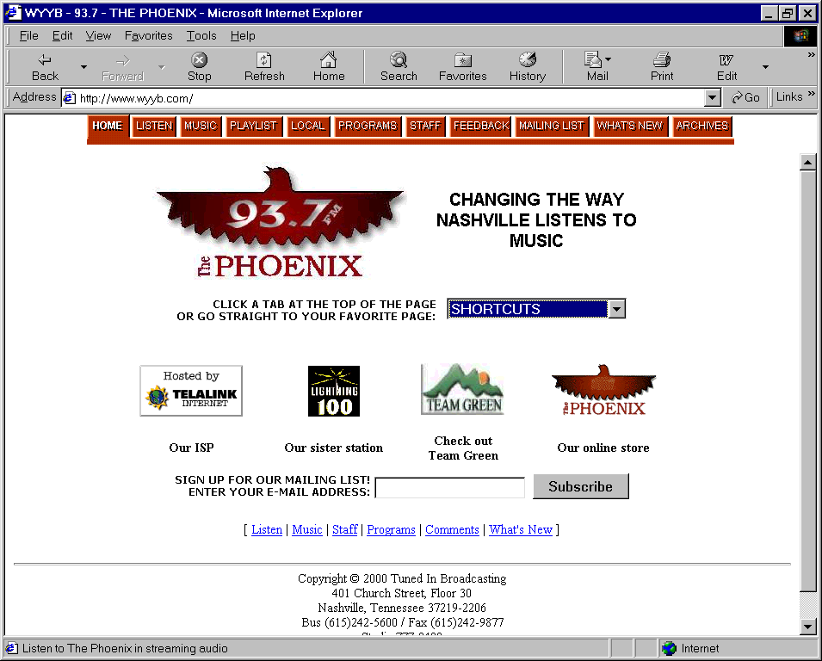
Figure 1: Home Page
Figure 2: Program Schedule Page
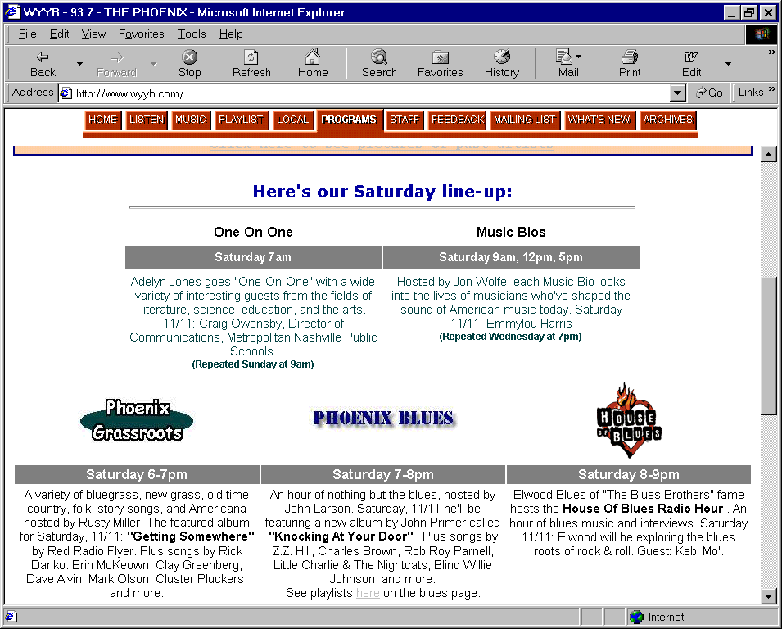
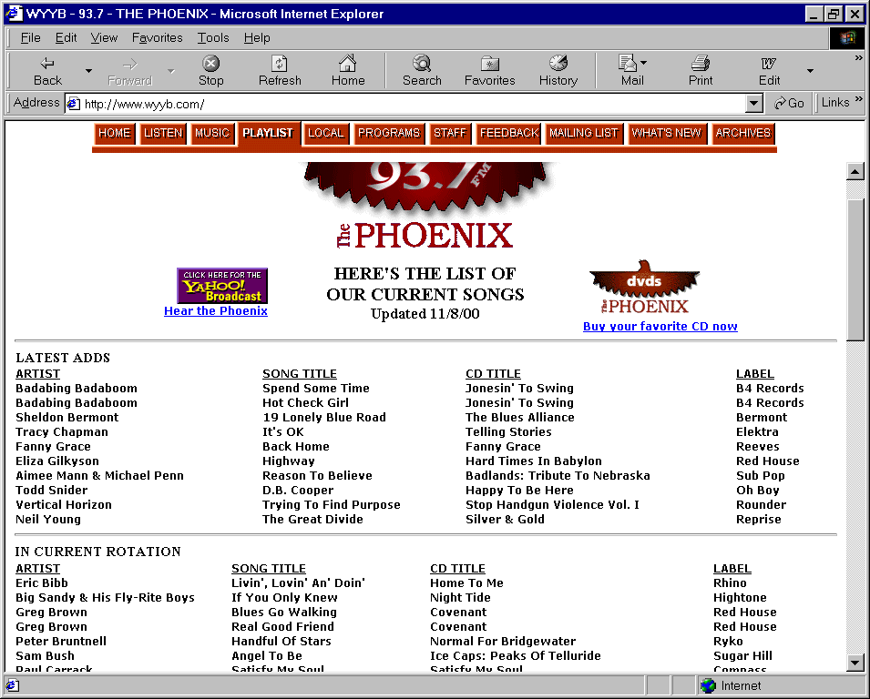
Figure 3: Playlist Page

Figure 4: Staff Page
